
Anja Hopfstock is a cartographer and GIS-specialist with the Federal Agency for Cartography and Geodesy, Germany.
She started to work in the private cartographic sector in Germany. In late 1992 she joined the Cartographic Department of the Federal Agency for Cartography and Geodesy in Frankfurt and was mainly engaged in the Topographic Information and Update Service. In 1996 she moved to the Department of Geoinformation and since then she has been involved in several international cooperation projects serving the setup and maintenance of topographic databases at the European and global levels.
Anja received her MS in cartography from the Novosibirsk Institute of Engineers for Geodesy, Aerial Phototopography and Cartography (now Siberian State Academy of Geodesy), Novosibirsk, Russia, in 1991 and is currently a PhD candidate at the Cartographic Institute of the Technical University of Dresden.

A Comparative Study of European Topographic Maps at Scale 1:250,000
( WITH PARTICULAR EMPHASIS ON MOTORWAYS )
Anja Hopfstock
Supranational Geoinformation Systems, Department of Geoinformation,
Federal Agency for Cartography and Geodesy,
Richard-Strauss-Allee 11, D-60598 Frankfurt a.M.,
email: Anja.Hopfstock@bkg.bund.de
- Introduction
„Esperanto for geodata!“ [6] is a request for data standards defining properties as well as methods of portrayal for a feature to be shared in a spatial data infrastructure.
INSPIRE (Infrastructure for Spatial Information in Europe) demands view services making it possible to display or overlay spatial datasets and to display legend information and relevant metadata [10]. Although available harmonised European topographic reference datasets, e.g. EuroRegionalMap (ERM) and EuroGlobalMap (EGM) from EuroGeographics, promote its usage as a geographic backdrop for visualisation and presentation of other thematic data in cross-border applications, concepts for presenting the collected harmonised data in an effective, understandable and harmonised way are missing.
In 2005 at the XXII International Cartographic Conference in La Coruña, the author discussed the question of a common design for topographic maps in Europe [3] and outlined the framework for a comparative study of European topographic maps at scale 1:250,000. In this paper, the proceeding from the inventory of map symbols to the definition of symbol assignment rules is illustrated at the example of motorways.
- Inventory
Topographic maps are detailed and accurate graphic representations of characteristic natural and cultural features on the ground, such as relief, water, vegetation, transportation network, urban development, and toponomy. The level of detail shown on the maps depends on the map scale. In general, topographic topographic maps are divided into large, medium and small scale maps. According to Robinson et. al. [5], medium scale maps are at scale smaller than 1:50’000 and larger than 1:500’000. These maps cover a large area and therefore give a geographic and topographic overview of the entire area. They are especially suitable for the management of the transportation network (planning of road and railway projects to develop the transportation network), and to motorists for route planning and navigation. Consequently, the transportation network is the major element of these maps.
For the purpose of the comparative study, official topographic maps of 12 National Mapping and Cadastral Agencies (NMCAs) and 12 road maps of commercial map publishers from all over Europe are reviewed at a scale range 1:160,000 to 1:250,000. Throughout the paper official topographic maps are called "topographic maps" (TP) whereas road maps produced by commercial publishers herein after called "road maps" (RM). From the map legends and symbol catalogues single symbols and their descriptions are extracted and collected to tables organised by themes common to topographic maps. This collection is analysed based on the semantics and the graphical representation to identify national road classification, symbol design and labelling. Hereafter, results are presented for road classification and methods of portrayal.
  - Road classification
The transportation network is an important structural and functional element of the man-made landscape and builds the spatial organisation of a country or region. On the one hand roads connect regions, on the other hand they divide an area/landscape into regions. Transportation of goods from a producer to the market as well as the growing mobility of the society requires a well-structured transportation network. Thus, it is an indicator of the economic competitiveness and sustainable development of a country or region.
The importance of the transportation network is reflected by its graphical representation on topographic and road maps at medium scale. In the reviewed map legends on average 50 % of the space is dedicated to the description of the transportation network, including roads, railways, airport/airfields, and other features related to the transportation network. Beside the visible structural elements of the landscape, such as roads and railways, also non-visible elements, such as ferry crossings and roads under construction or even proposed roads are shown on the maps.
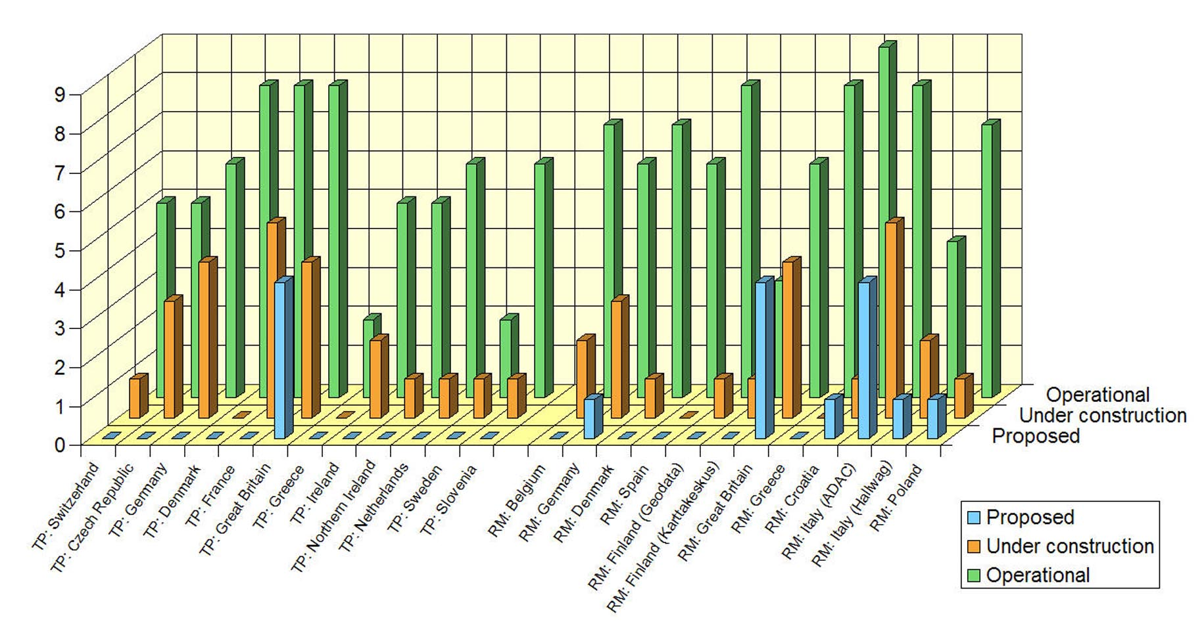
Figure 1 Number of Road Classes
In general, 2-9 classes represent the road network of a country. Figure 1 depicts the number of road classes in operation (in green), the number of road classes under construction (in orange) and the number of road classes for proposed roads (in blue) listed in the map legends. All reviewed road maps contain a road class or road subclass “Motorway”. This is the top road class in the classification. The topographic maps use the term “Motorway” too, but with some exceptions. For instance in the topographic map of the Czech Republic [TP2] the highest road class is called “Highway” followed by a road class “Motorway”. In this study, only the class “Highway” is considered as the symbol reflects the geometric characteristics of a motorway. The topographic map of the Netherlands [TP10] features a road class “Dual highway”.
Roads under construction are shown on 20 of 24 maps. In the majority of these cases construction sites are considered for motorways only. A few topographic maps, like those of Great Britain and Germany, show construction sites for all main road classes. Only the topographic maps of Denmark [TP4] and Greece [TP7] do not indicate any road construction sites. These features are also missing on the road maps [RM4] and [RM8].
Proposed roads are shown on 6 of 12 road maps, whereas these features are in general missing on topographic maps. Only the topographic map of Great Britain [TP6] shows proposed roads for the main road network.
  - Methods of portrayal
In general, roads on maps are represented as lines indicating their position on the ground. They are portrayed as symbols with black or coloured double casings and a colour fill. Table 1 presents the different methods of portrayal used to show motorways on maps at medium scale.
N° | Method of Portrayal | Graphical Presentation | Occurrence
1 | Colour broad double casing with colour fill | 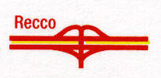 | TP: [TP5]  RM: [RM2], [RM4], [RM10], [RM12]
2 | Black thin double casing with colour fill |  | TP: [TP1], [TP6], [TP9]  RM: -
3 | Black/Colour thin double casing with thin centerline and colour fill | 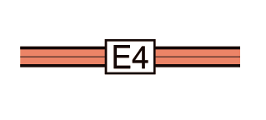 | TP: [TP2], [TP3], [TP4], [TP8], [TP10], [TP11], [TP12]  RM: [RM3], [RM6], [RM7], [RM9]
4 | Black/Colour thin double casing with colourful broadening inwards and solid centerline at different colour |  | TP: -  RM: [RM1], [RM5], [RM8]
5 | Black/colour thin double casing with two thin centerlines and a solid line at different colour | 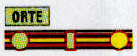 | TP: -  RM: [RM11]
Table 1 Methods of Portrayal of Motorways
The width of the motorway symbol ranges from 1,1 mm on the road map for Finland [RM5] to 1,8 mm on the road map for Italy [RM11]. The mean width of the motorway symbol is calculated as 1,44 mm.
The colours used for the broad double casing of portrayal method N° 1 in Table 1 are either red on road maps [RM2], [RM10] and [RM12], or blue on the road map [RM4] and on the topographic map [TP5]. The colour range used for the thin double casing of portrayal methods 2 and 3 consists of black, grey, red and brown. The colour fill used in all portrayal methods ranges from red, blue, yellow and orange with overall three occurrences over red/yellow and light blue with two occurrences to green/yellow, white, green and violet with one occurrences.
- Design guidelines
The Swiss Society of Cartography defines in [7], p.14: “A good map design transmits spatially related information in an optimal manner. It restricts itself to the essential substance of available information and removes unnecessary and insignificant items from the map image. Moreover it guarantees the desired positional precision and applies a symbolisation which allows for spontaneous and correct association.”
As there is no historically grown European cartography, the common principles of representing motorways identified by the inventory should be used to design a common graphical representation of motorways for pan-European topographic reference datasets.
  - Road classification
In 1976, Berger [1] proposes a common European road classification with 5-6 categories. Motorways make the highest road category, followed by dual carriageways with motorway characteristics, and further by two or three additional categories classified by the width of the road, the construction type or traffic importance. In 1987, Ertl [2] recommends to build modern road classification based on geometric-structural and functional parameters. Geometric-structural parameters are the construction type of a road, its width, the number of lanes, and the road surface type. Whereas, traffic importance, the administration of roads and any restrictions to the use depict functional parameters. The top category of Ertl’s proposed road classification form roads that do not cross at level with other roads.
Moreover, according to the UNECE “European Agreement on Main International Arteries (AGR)” [8], the main international traffic arteries should preferably be motorways or express roads. Motorways in this agreement are defined as roads designed and built for motor traffic having separate carriageways for the two directions of traffic separated from each other by a dividing strip not intended for traffic. Further on, they do not cross at level with any road, railway or tramway track, or footpath. Finally these roads are especially sign-posted as a motorway.
The inventory of topographic maps at medium scale proves that motorways are roads of special importance within the main transportation network. The top category of a European road classification should form motorways.
  - Methods of Portrayal
The map graphic for motorways should explicitly reflect the road classification as well as the geometric characteristics and should be easy to comprehend. They should stand out clearly against other themes and features on the map.
The proposal of Ertl [2] to relate each classification parameter with its own graphical expression is interesting but challenging. As roads are represented by lines, they can easily be varied in size depending on the width of the road and by hue depending on the road class. More complex symbols have to be defined to reflect other geometric-structural and functional parameters of the road network, for example road surface type or toll category.
Table 1 reveals that for motorways the combination of thin double casings with a thin centerline and a colour fill is the most popular method on topographic maps. This method of portrayal is preferred as it reflects the fundamental characteristics of construction and improvement of a motorway. Road maps use a greater variety of portrayal methods.
Neudeck [4] states that colour (hue and chroma) for the road network should stand out clearly against other colours. He recommends red and orange as suitable colours to represent roads. The inventory revealed that red is one of the preferred colours to represent motorways, either for the broad double casing ([RM2], [RM10], [RM12]) or the colour fill ([TP4], [TP11], [TP12], [RM3]). The preferred colours for the thin double casing and thin centerline are black (10) and grey (4).
In some cases, like the road colour fill in [TP6] or the colour of the broad double casing in [TP5] of the motorway symbol correlate with the colour coding system of the national road network. This correlation make spontaneous and correct association possible, but is not suitable in the European context as countries use different colour coding systems for their national road network.
- Proposal for a European symbol catalogue
A European symbol catalogue for the scale 1:250,000 aims at defining the content and format for symbols that support the visualisation of pan-European topographic datasets at medium scale. It consists of the symbol assignment rules and symbols to create a harmonised, seamless cross-border geographic backdrop from digital vector data. The following proposal of symbol assignment rules is built on the current version of the ERM specification [9]. The symbols are designed based on the above discussed design guidelines.
  - Symbol assignment rules
The ERM specification for roads contains all geometric-structural and functional parameters to build a road classification as proposed by Ertl [2]. Table 2 lists the ERM attributes standing for the geometric-structural and functional parameters of roads. Mandatory ERM attributes are given in bold.
Geometric-structural parameters | Functional parameters
Median Category (MED) | Route Intended Use (RTT)
Location level (LLE) | Existence Category (EXS)
Lane/Track number (LTN) | Transportation Use Category (TUC)
Road Surface Type (RST) | Toll Category (TOL)
 | Seasonal Availability (RSU)
Table 2 Classification parameters according to Ertl
Figure 2 provides a graphic depiction of the symbol assignment rules allocating a symbol to a specific combination of geometric-structural and functional parameters for motorways. RST is excluded from the rules as it is assumed that motorways are generally paved. The attributes TOL and RSU as optional parameters have not yet been included in the rules.
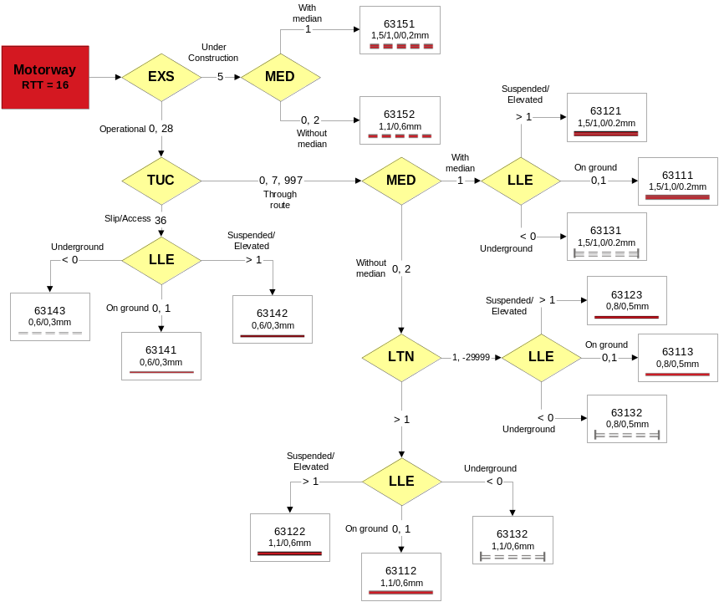
Figure 2 Symbol assignment rules and symbols for Motorway
  - Experimental investigations
To assess the feasibility of the proposed design guidelines, the symbol assignment rules and symbols for the European symbol catalogue are implemented into “SignaTool”. This tool is a variable, data driven tool based on the ESRI ArcMap technology. It was developed by BKG to allow a quick visualisation of digital topographic vector data for viewing and quality control. Results are presented in Figure 3.
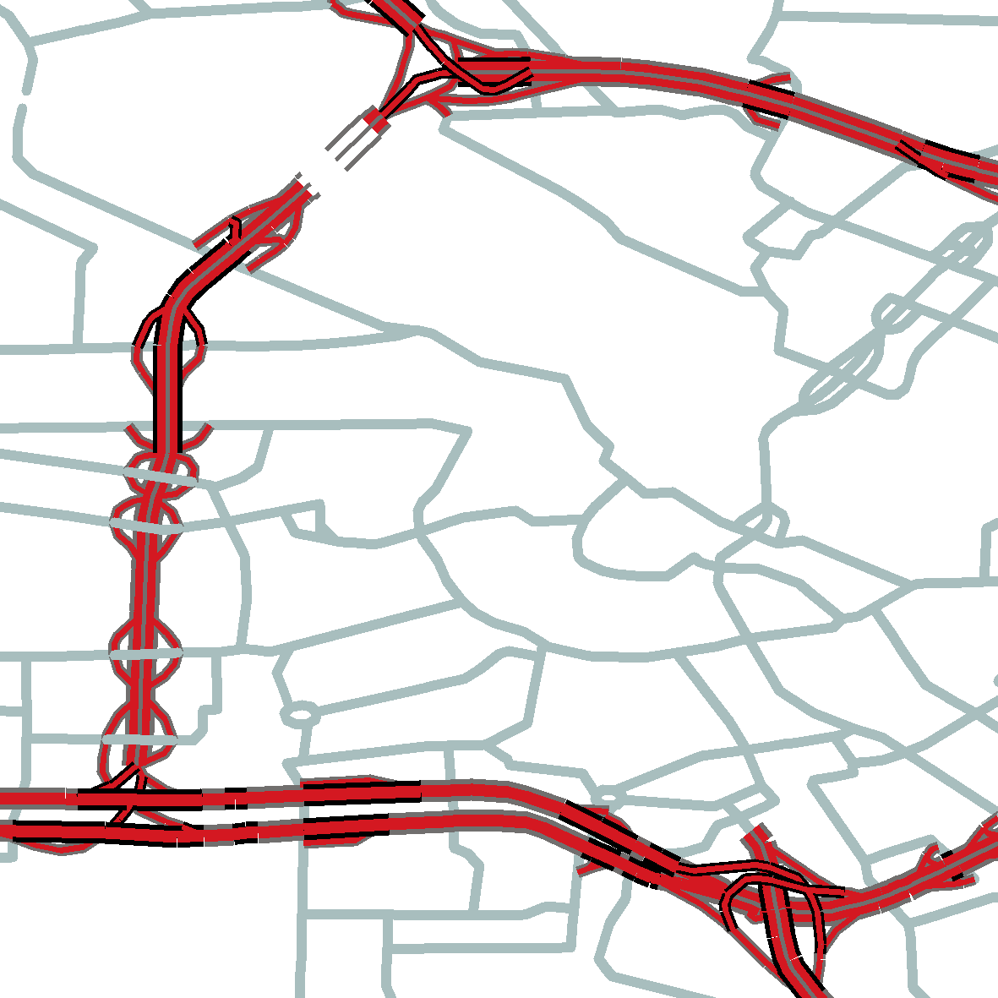 | 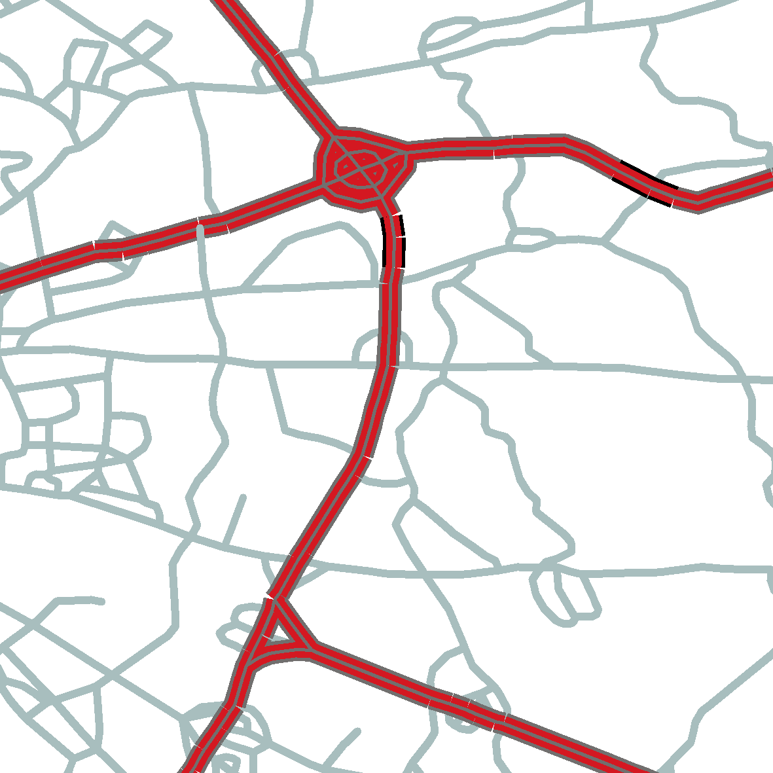 | 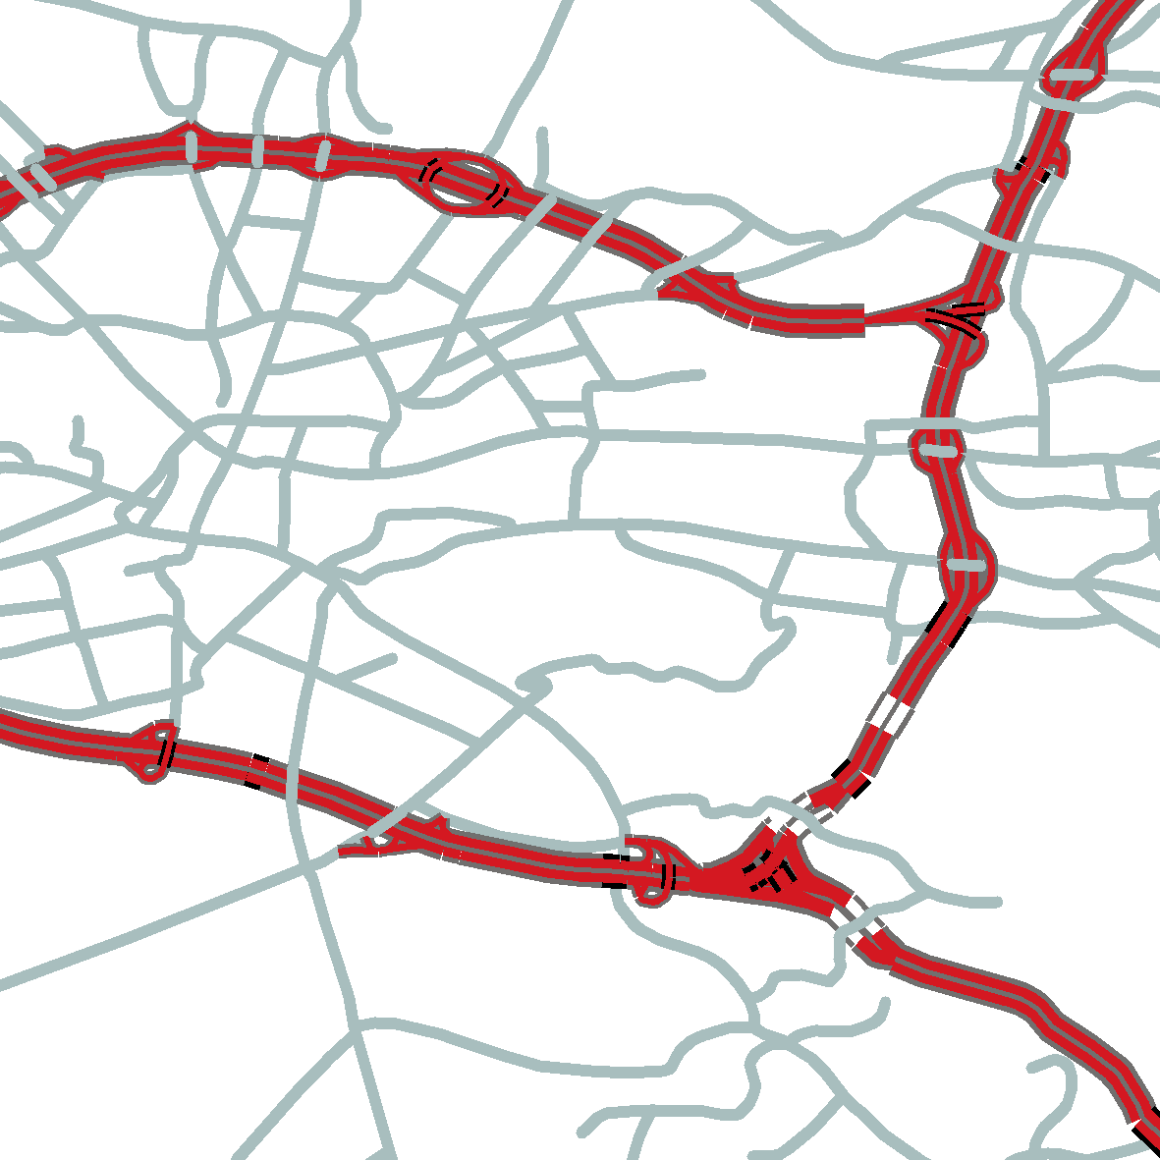
© Kadaster and Openbare Registers, Netherlands & EuroGeographics | © Instituto Geografico Militare Italiano, Italy & EuroGeographics | © Geodetska uprava republike Slovenije, Slovenia & EuroGeographics
Figure 3 Examples of visualisation for ERM motorways
  - Discussion
A major challenge in establishing a harmonised European Symbol Catalogue is to reflect the harmonisation effort of the national datasets and at the same time representing the different landscapes, regions and countries with their cultural differences. The handling of mandatory and optional attributes for data visualisation of ERM turned out to be challenging as well. The ERM concept of mandatory and optional features and attributes was introduced considering the importance of features and attributes to the user as well as the different content and level of development of national databases (see [9]). While it supports data collection throughout Europe, it might contradict the principle of comparability of the seamless and harmonised European data. As for the user it is not clear whether the optional content of ERM is not available in reality or just missing due to a lack of information in the dataset, assigning symbology based on optional features and attributes might mislead the user in the interpretation of the map.
Further more, cartographic generalisation needs to be applied creating a European topographic map product because the degree of generalisation varies between the national datasets used to build ERM upon.
Finally, a harmonised European symbol catalogue should be built in such a way that assigning symbology to features based on their attribution is flexible and separated from the spatial data itself. The portrayal of data should be technology-independent.
- Conclusions and further work
Based on the inventory of 12 topographic maps from NMCAs and 12 road maps from commercial map publishers from all over Europe, design guidelines for a harmonised European symbol catalogue are described. The feasibility of the proposed guidelines are explored by experimental investigations in visualisation of ERM.
The work on a European symbol catalogue based on common principles of European topographic and road maps is carried forward. Together with the ERM specification, the symbol catalogue meets the request for data standards defining properties as well as methods of portrayal for a feature to be shared in a spatial data infrastructure.
- References
- Berger, Arno: Die Darstellung der Straßen in topographischen Karten Westeuropas. In: AVN 2/1976, pp.47-58
- Ertl, Roman: Vergleich der Zeichenschlüssel amtlicher europäischer Kartenwerke des Maßstabes 1:50000 - eine Aktualitätsprüfung. Bundesministerium für Landesverteidigung, Wien, 1987
- Hopfstock, Anja: A Common Design for Topographic Maps in Europe? In: Proceedings of XXII International Cartographic Conference, La Coruña, 2005
- Neudeck, Stefan: Zur Gestaltung topographischer Karten für die Bildschirmvisualisierung. Universität der Bundeswehr. Studiengang Geodäsie und Geoinformation. München, 2001
- Robinson et. al.: Elements of Cartography. John Wiley & Sons, Inc., 1995
- Wille, Bernd: Esperanto für Geodaten. Business Geomatics, 1/2007, p. 24
- Swiss Society of Cartography: Topographic Maps: Map Graphics and Generalisation, Cartographic Publication Series No. 17, 2005
- UNECE. Road Transport Infrastructure-European Agreement on Main International Traffic Arteries (AGR). http://www.unece.org/trans/main/sc1/sc1agrfdoc.html (accessed May 17, 2007)
- EuroGeographics (2007): EuroRegionalMap Specification and Data Catalogue. http://www.eurogeographics.org/eng/03_projects_erm_deliverable.asp (accessed May 17, 2007)
- INSPIRE Directive. http://www.ec-gis.org/inspire/directive/l_10820070425en00010014.pdf (accessed May 17, 2007)

Maps
- Strassenkarte der Schweiz 1:200,000. Bundesamt für Landestopographie, 2001
- Catalogue of map symbols: Map of Regions 1:200,000. Czech Office for Surveying, Mapping and Cadastre. 01.03.2004
- ATKIS-Signaturenkatalog 1: 250’000. Version 1.0, AdV, 2006
- Færdselskort Danmark 1:200,000. Kort og Matrikelstyrelsen, 2004
- Carte Régionale Alsace Lorraine 1:250,000. Institut Géographique National, 2003
- OS Travel Map – Road 1 :250’000. Ordnance Survey of Great Britain, 2002
- Koroni 1:250,000. Hellenic Military Geographical Service, 1979
- Road Atlas Specification 1:210’000. Ordnance Survey of Ireland, 2003
- Holiday Map 1:250,000. Ordnance Survey of Northern Ireland
- Wegenkaart van Nederland 1:250,000. Dienst voor het Kadaster en de openbare registers, 2004
- Översiktskartan 1:250'000. Lantmäteriet Sweden
- Državna Pregledna Karta 1:250'000. Geodetska uprava Republike Slovenije

- Regional Benelux Belgique Sud 1 :200'000. Michelin et Cie, 2005
- Travelmag Reisekarte Deutschland 8 1:200'000. GeoGraphic Publishers, 2003/2004
- Die Generalkarte Dänemark 1:200,000. Mairs Geographischer Verlag, 2002
- Berndtson MAP Mallorca 1:160'000. Berndtson & Berndtson, 2004
- WSOY TIEKARTAT 10 Oulu 1:250,000. Geodata Oy, 1998
- Tiekartta GT 10 Oulu-Ylivieska 1:200,000. Karttakeskus Oy, 2000
- National Travel Map Southern England 1:250'000. HarperCollinsPublishers Ltd., 2005
- Road Editions 5 Peloponnese 1:250,000. Road Editions S.A.
- Road map Croatia North 1:200'000. Freytag & Berndt
- Toskana ADAC Urlaubskarte 1:200,000. Ed. ADAC Verlag GmbH
- Euro map Lombardia 1:250'000. Ed. Hallwag International
- Strassenkarte Polen Hinterpommern 1:200'000. Höfer Verlag

